**Task 3: EC2 Instance Setup with Username/Password Authentication**

**Step 1: Spin up an EC2 Instance**

1.1. Login to AWS Management Console:

* Open your web browser and navigate to the AWS Management Console.
* Enter your credentials to log in.

1.2. Navigate to EC2 Dashboard:

* Click on the "Services" dropdown menu at the top left corner.
* Select "EC2" under the "Compute" section.
* Click on the "Launch Instance" button to start the instance creation process.

1.3. Choose an Amazon Machine Image (AMI) and Instance Type:

* Select the desired AMI, such as CentOS or Ubuntu.
* Select the "t2.micro" instance type.

1.4. Configure Instance,Add Storage, Configure Security Group:

* Configure instance details including VPC, subnet, auto-assign public IP, etc.
* Configure the storage settings for the instance.
* Create or select an existing security group with SSH (port 22) and any other necessary ports open.

1.5. Review and Launch:

* Review the instance configuration and click on "Launch".

1.6. Create a new Key Pair:

* If you don't already have a key pair, create a new one and download the private key file (.pem).
* Click on "Launch Instances" to start the EC2 instance.

**Step 2: Enable Username/Password Authentication**

2.1. Connect to the EC2 Instance:

* Use an SSH client (e.g., PuTTY) or terminal or to connect to the instance using the private key:
* Command used for connect to the instance:

ssh -i /path/to/private-key.pem ubuntu@your-instance-public-ip

2.2. Modify SSH Configuration:

* Edit the SSH server configuration file:
* Command used for edit the SSH configuration file:

sudo nano /etc/ssh/sshd_config

* Change PasswordAuthentication no to PasswordAuthentication yes.

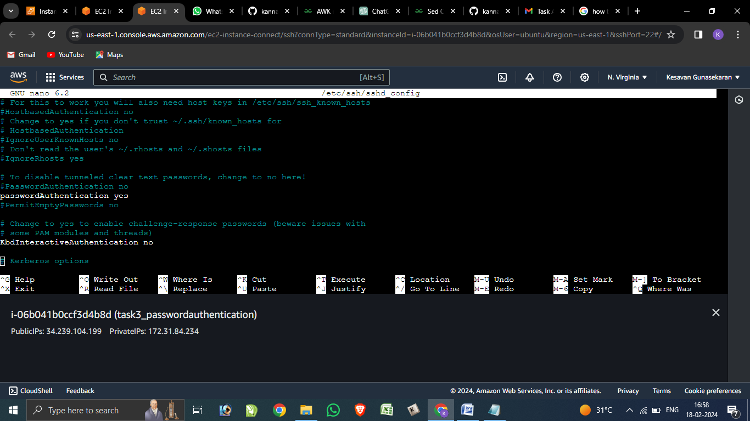

2.3. Restart SSH Service:

* Restart the SSH service to apply the changes:
* Command used for restart the SSH service :

sudo systemctl restart sshd

2.4. Set Password for User:

* Set a password for the user you want to log in with:
* Command used for set a password for the user:

sudo passwd ubuntu

2.5. Test Connection:

* Ensure you can now log in using SSH with the username and password:
* Command used for login into the instance with the username and password:

Ssh ubuntu@your-instance-public-ip

